A Web server exclusively handles HTTP/HTTPS requests. It serves content to the web using HTTP/HTTPS protocol.

An application server serves business logic to application programs through any number of protocols, possibly including HTTP.

 An application server thus offers much more services than an web server which typically include:

* A (proprietary or not) API
* Load balancing, fail over...
* Object life cycle management
* State management (session)
* Resource management (e.g. connection pools to database)

IIS is a web server; SharePoint is an application server.

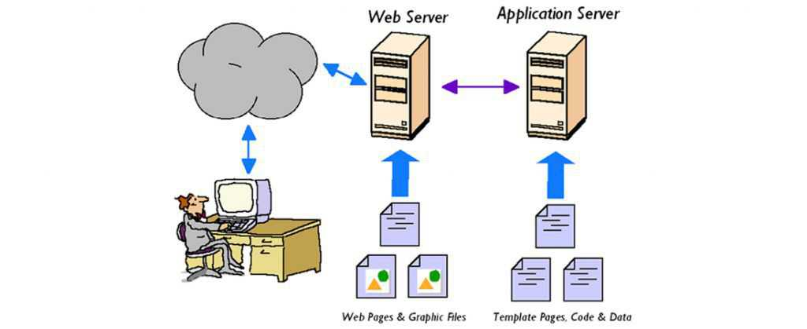

|  |  |  |
| --- | --- | --- |
|  | **Application Server** | **Web Server** |
| Short descriptions | An application server is a software framework that provides an environment in which applications can run, no matter what the applications are. | A web server can refer to either the hardware or the software that helps to deliver web content that can be accessed through the Internet. |
| Basically, they do | It transfers the business logic to client applications through various protocols including HTTP. | It only handles the HTTP protocol. |
| Functions | Its function is to deliver various applications to another device; it allows everyone in the network to run software off of the same machine. | Its function is to keep the HTML, PHP, and ASP, etc. files available for the web browsers to view when a user accesses the site on the web, handles HTTP requests from clients. |
| Other usage | It is also used to serve the web based applications and enterprise based applications. | Along with the hosting of the websites, the web servers are also used on other applications such as gaming, data storage or running enterprise applications. |
| Resource utilizations | The resource utilization is low here. | The resource utilization is more here as compared to the application servers. |
| Examples | Sun Java Application server, Apache Geronimo, IBM WebSphere Application Server, Glass Fish Server, etc. | Apache, Microsoft IIS, Tomcat, Jetty, etc. |